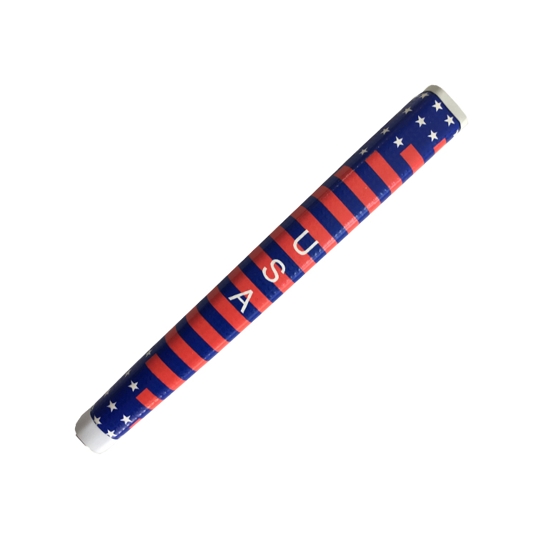
Ready to Ship
【Upgraded Tape】2"*10" Professional Tape, 0.2mm thickness, Easy to be activated by Solvent, Easy to be removed next time regriping.
【ERGONOMIC SHAPE】Special pistol shape for a perfect fitting in your palms thus aiming much more precisely.
【ANTI-SLIP】Tacky Surface Coating Technology and Unique boomerang-shaped embossing patterns bring extra traction and help you achieve consistant strokes in your rounds of golf.
【LIGHT WEIGHT】Light core with PU Wrap, which helps you feel better the clubs.

